Dip. Juanita Guerra Mena
Presidenta (Morena)
Dip. Ulises Murguía Soto
Secretario (Morena)
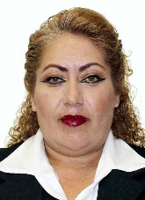
Dip. María Guadalupe Román Ávila
Secretaria (Morena)
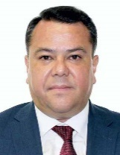
Dip. Raúl Ernesto Sánchez Barrales Zavalza
Secretario (Morena)
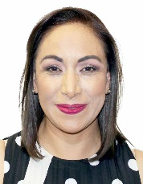
Dip. Adriana Dávila Fernández
Secretaria (PAN)
Dip. Felipe Fernando Macías Olvera
Secretario (PAN)
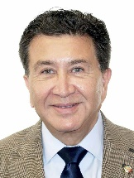
Dip. Héctor Yunes Landa
Secretario (PRI)
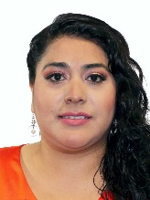
Dip. Esmeralda de los Ángeles Moreno Medina
Secretaria (PES)
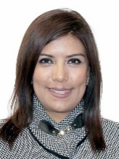
Dip. Carmen Julia Prudencio González
Secretaria (MC)
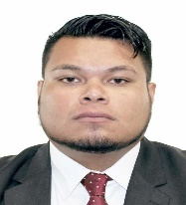
Dip. Pedro Daniel Abasolo Sánchez
Integrante (MORENA)

Dip. María Guillermina Alvarado Moreno
Integrante (MORENA)
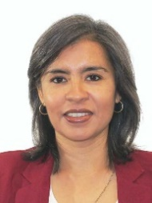
Dip. María Wendy Briceño Zuloaga
Integrante (MORENA)
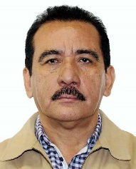
Dip. Rodrigo Calderón Salas
Integrante (MORENA)
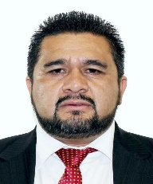
Dip. Gustavo Contreras Montes
Integrante (MORENA)
Dip. Alan Jesús Falomir Saenz
Integrante (MC)

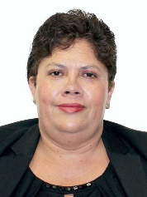
Dip. Julieta García Zepeda
Integrante (Morena)
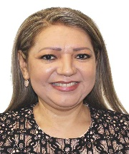
Dip. María Del Rosario Guzmán Avilés
Integrante (PAN)
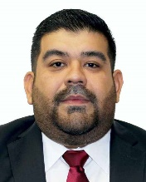
Dip. Francisco Javier Huacus Esquivel
Integrante (PT)
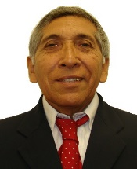
Dip. Limbert Iván de Jesús Interian Gallegos
Integrante (Morena)
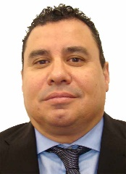
Dip. Francisco Jorge Villarreal Pasaret
Integrante (Morena)
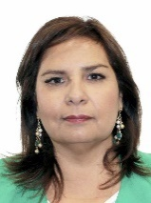
Dip. Beatriz Manrique Guevara
Integrante (PVEM)
Dip. Lizbeth Mata Lozano
Integrante (PAN)
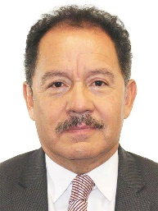
Dip. Moisés Ignacio Mier Velazco
Integrante (Morena)
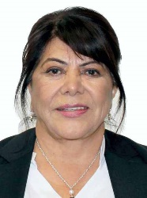
Dip. Carmen Mora García
Integrante (Morena)
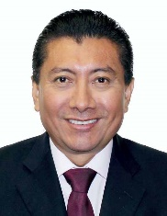
Dip. Jesús de los Ángeles Pool Moo
Integrante (Morena)
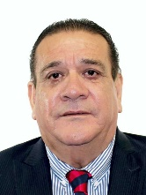
Dip. Alfredo Porras Domínguez
Integrante (PT)
Dip. José Ángel Pérez Hernández
Integrante (PES)
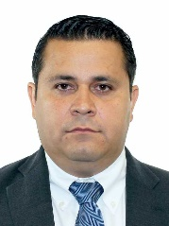
Dip. Armando Tejeda Cid
Integrante (PAN)
Dip. Irma María Terán Villalobos
Integrante (PRI)
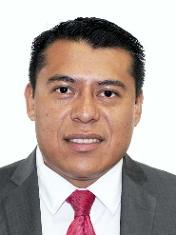
Dip. Rubén Terán Águila
Integrante (Morena)

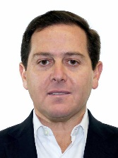
Dip. Pedro Pablo Treviño Villarreal
Integrante (PRI)
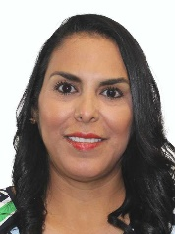
Dip. Mirtha Iliana Villalvazo Amaya
Integrante (Morena)
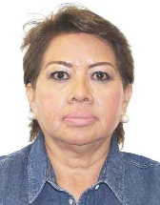
Dip. Ma. Guadalupe Almaguer Pardo
Integrante (PRD)
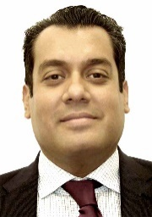
Dip. Sergio Carlos Gutiérrez Luna
Integrante (Morena)

